Environments in Postman

Click on the Manage Environment Button in the top right side

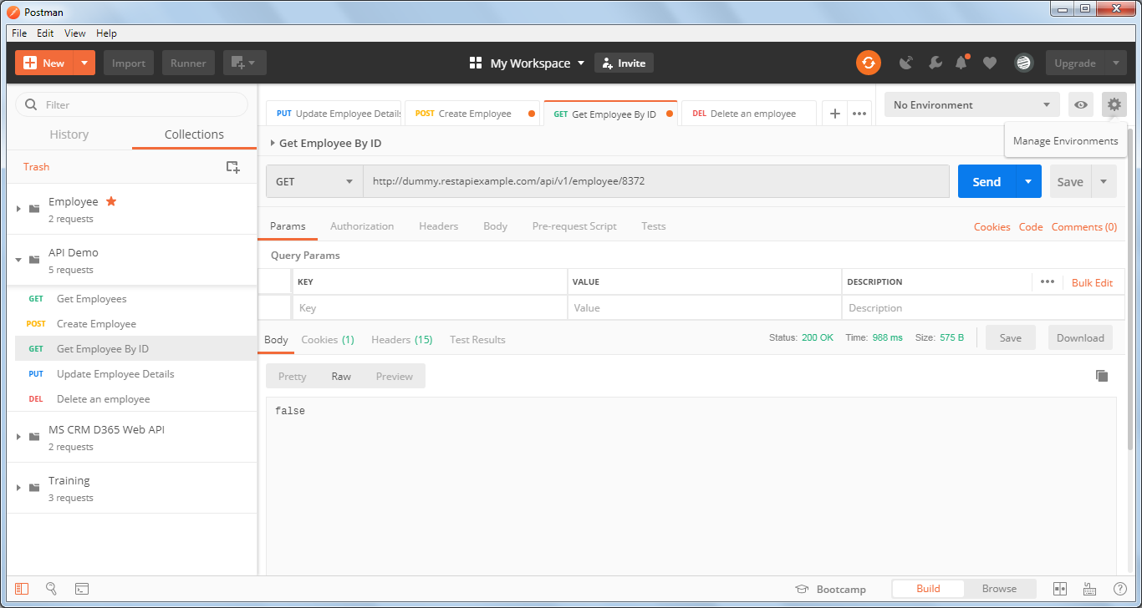

Click on Add

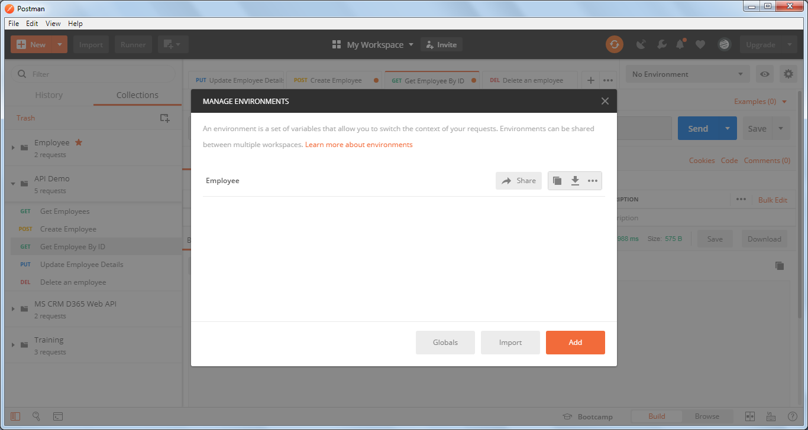

Give the environment name, variable and a value

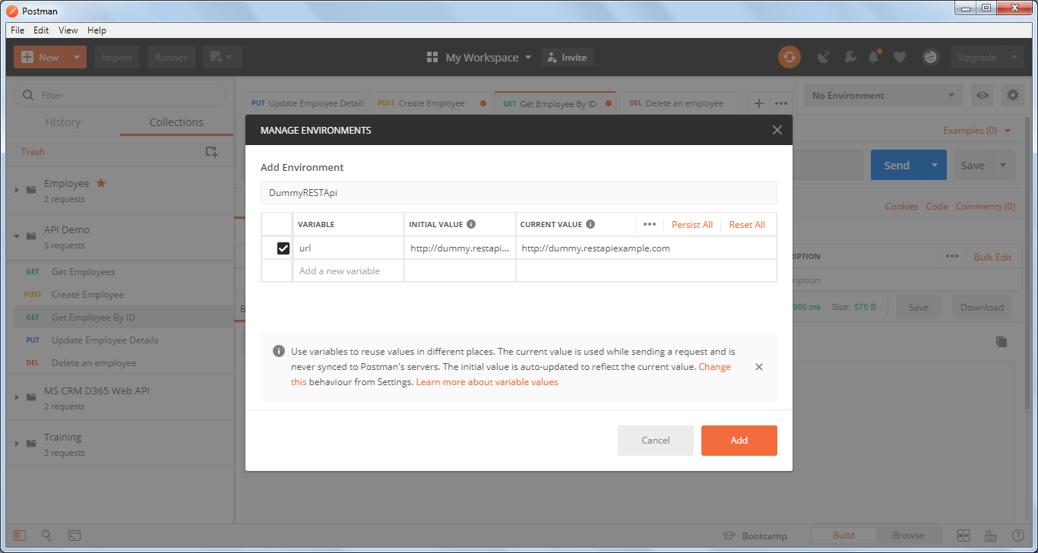

Click on Add and close the panel

Select the dropdown which says No Environment and select **DummyRESTApi** environment in that.

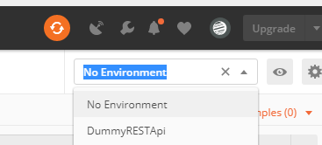

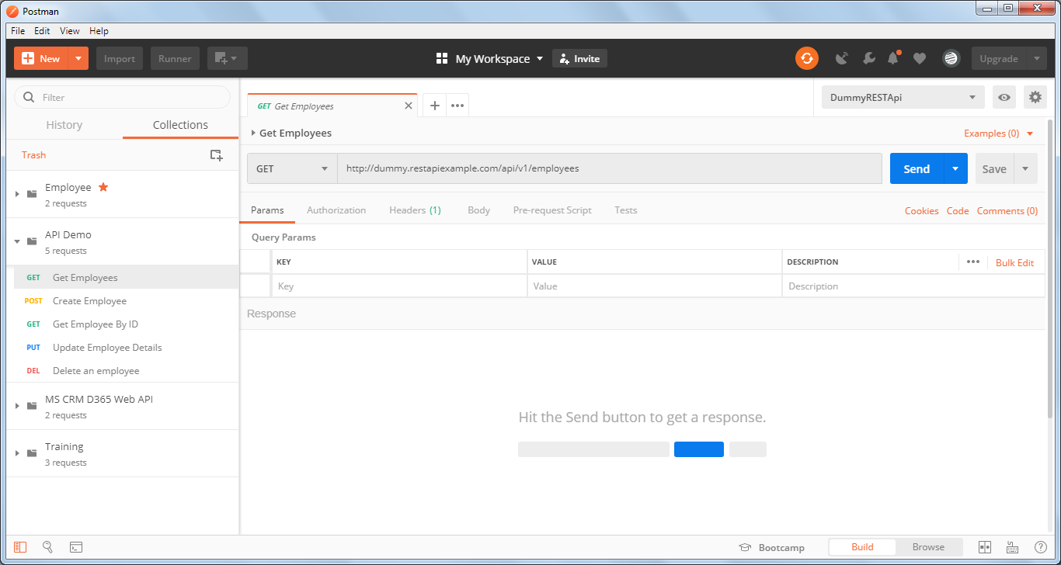

In the address bar change[**http://dummy.restapiexample.com**](http://dummy.restapiexample.com/api/v1/employees) to ***{{url}}***

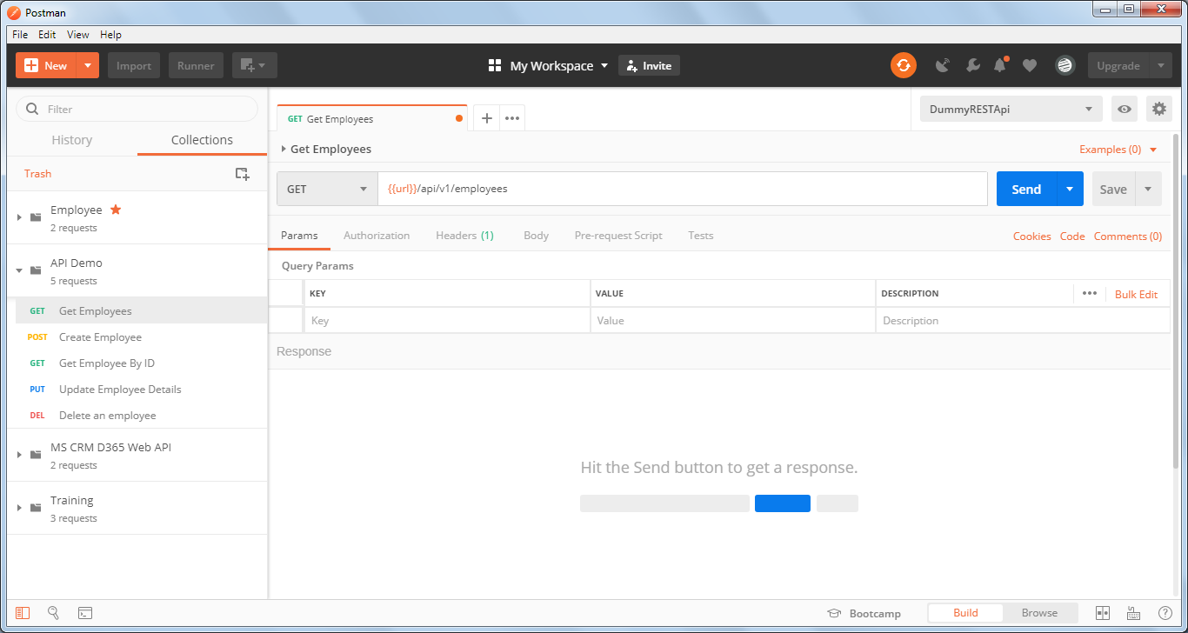

Click on Send

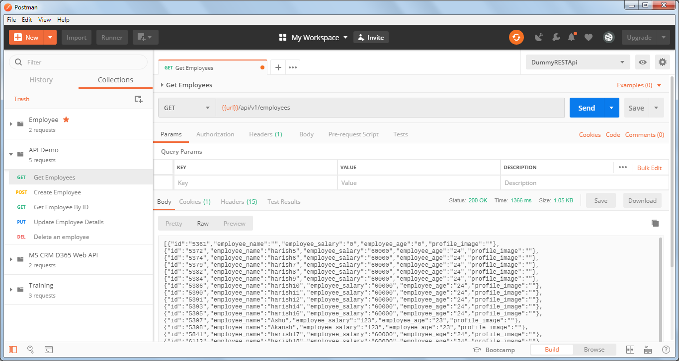

So, within Environment “DummyRESTApi” we have successfully created a local variable “url”

Global Variables:

Again click on the Manage environments button

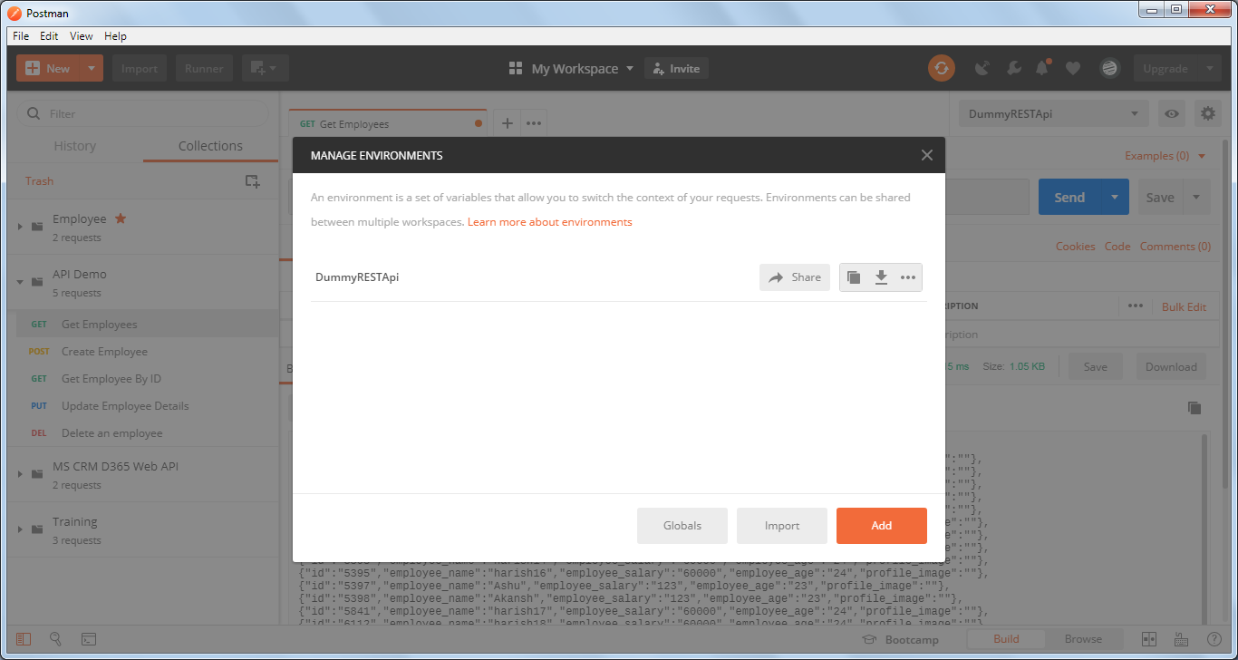

Click on Globals and enter variable name and value

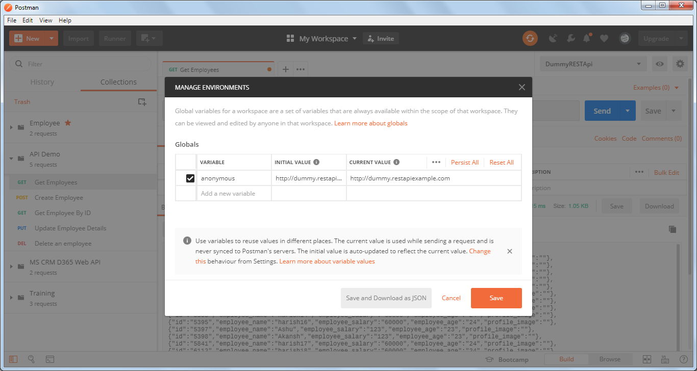

Click on Save

Click on the Quick look up button

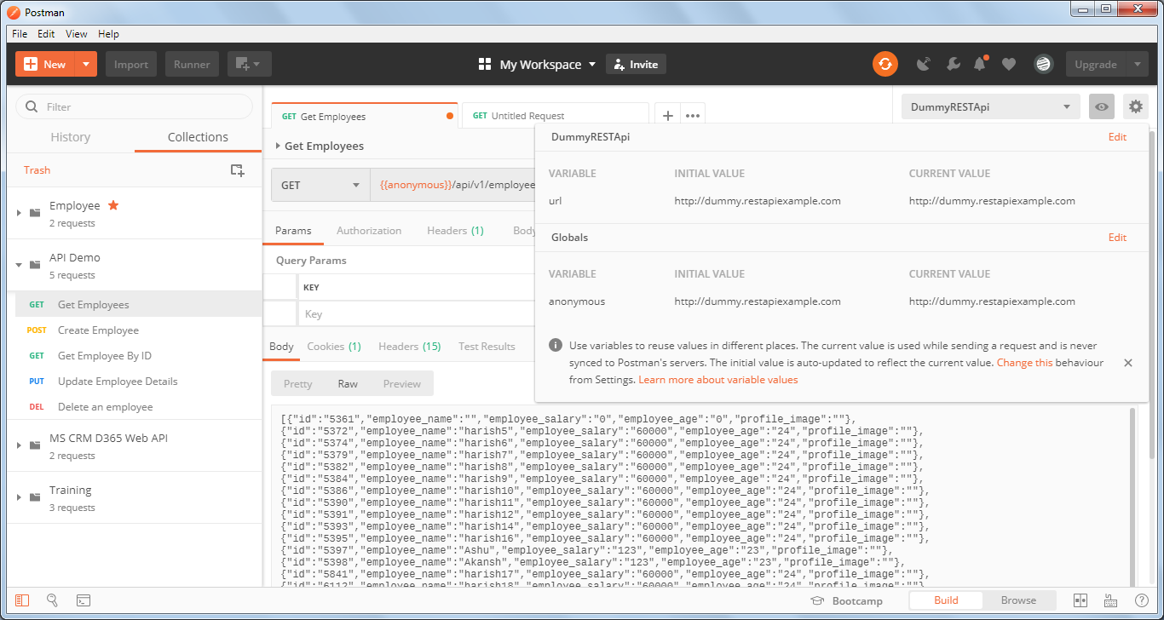

Both the variables are listed.

Select ‘No Environment’ from dropdown and replace the {{url}} with {{anonymous}} variable

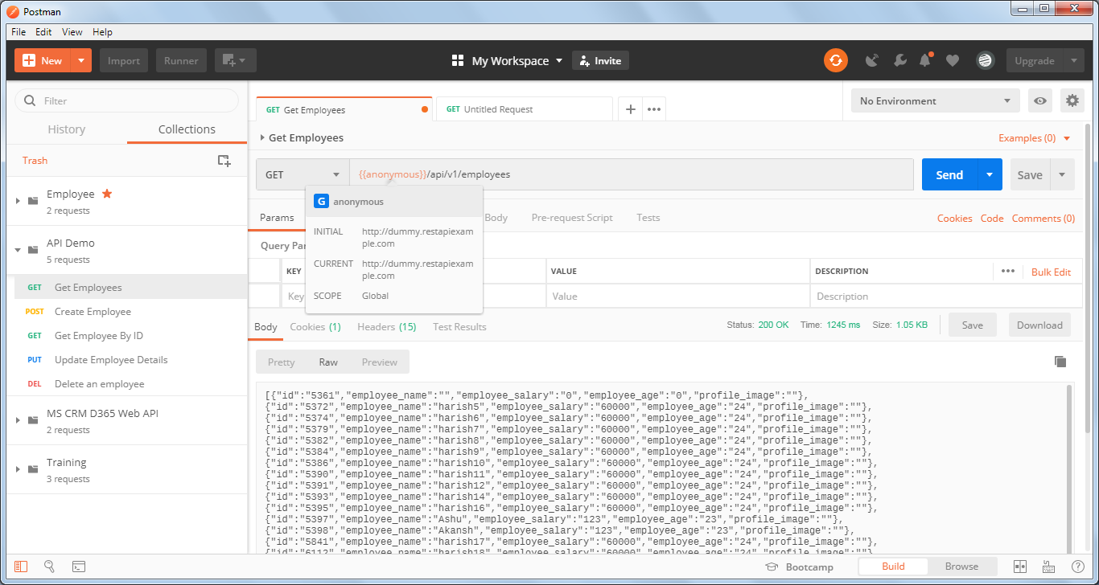

API worked successfully with the global variable.